CS 255 System Design Document Template

This template lays out all the different sections that you need to complete for Project Two. Each section has guidance to prompt your thinking. You will need to continually reference the interview transcript as you work to make sure that you are addressing your client’s needs. There is no required length for the final document. Instead the goal is to complete each section based on what your client’s needs are. Remove this note when you are finished, and replace all bracketed text with the relevant information.

UML Diagrams

UML Use Case Diagram
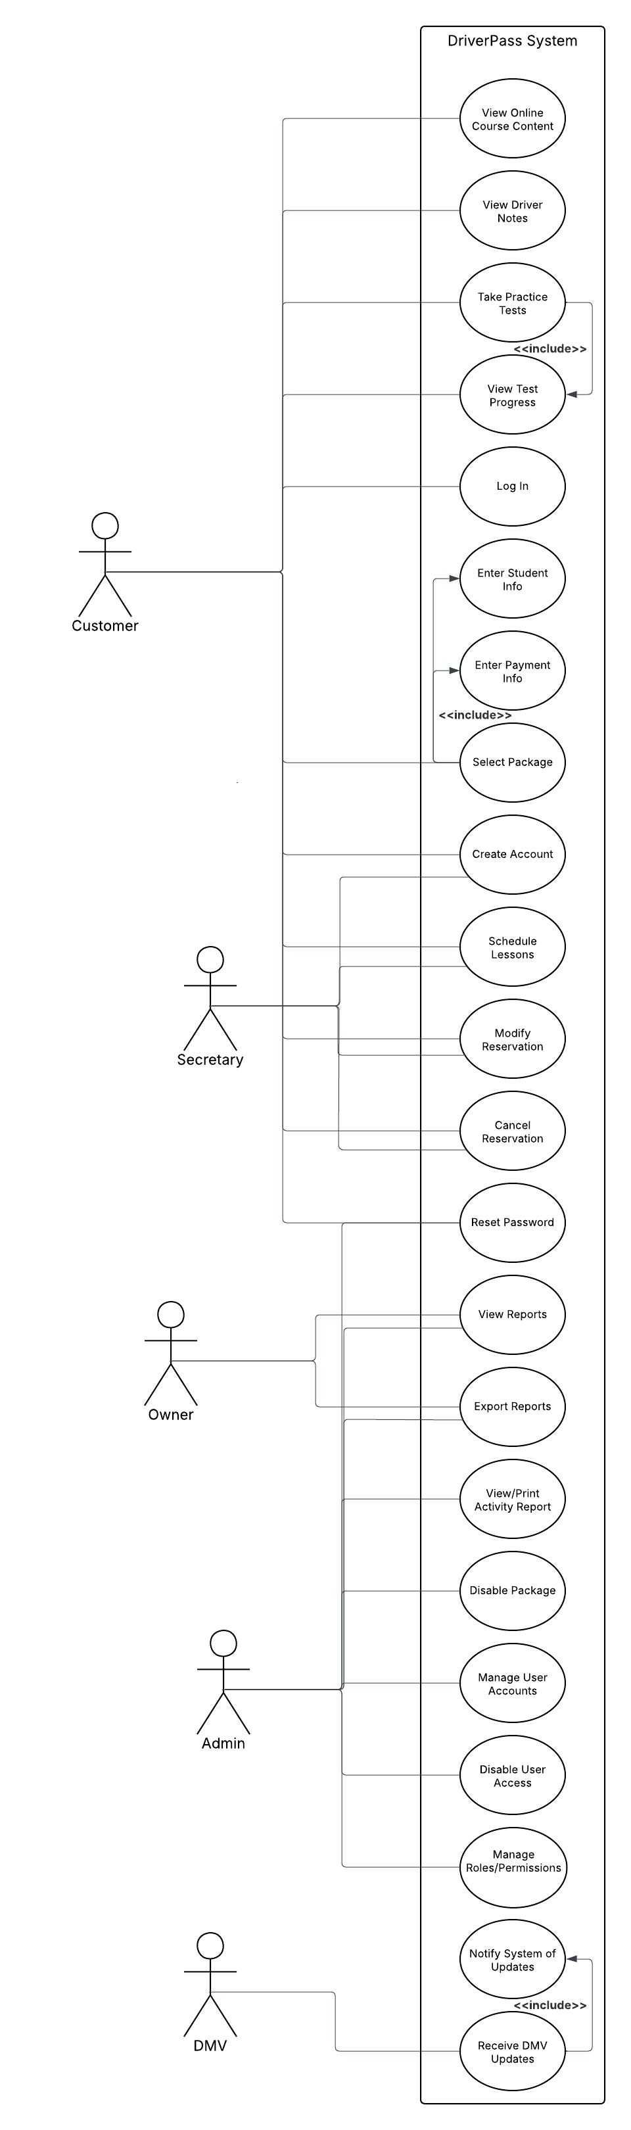

UML Activity Diagrams
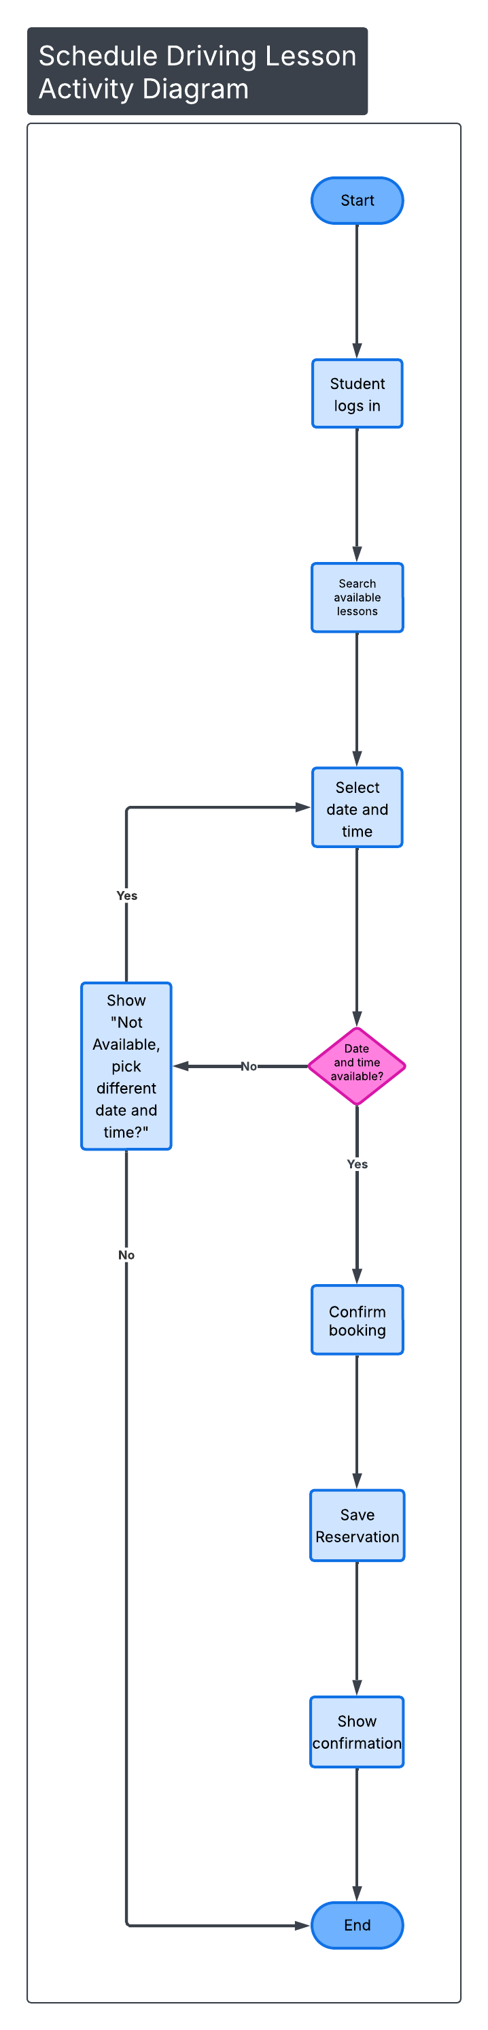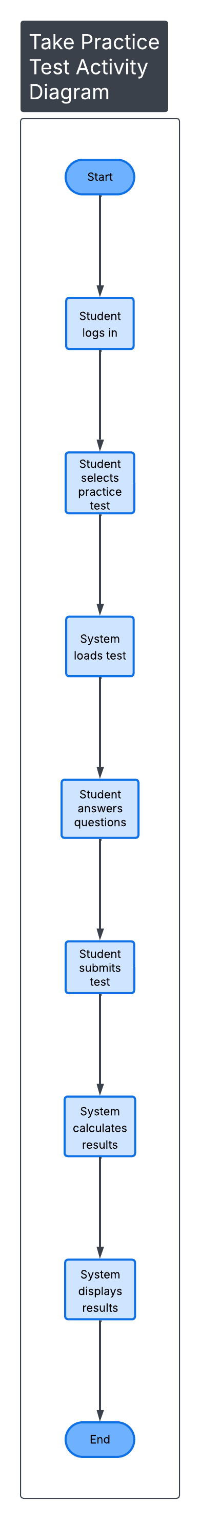

UML Sequence Diagram
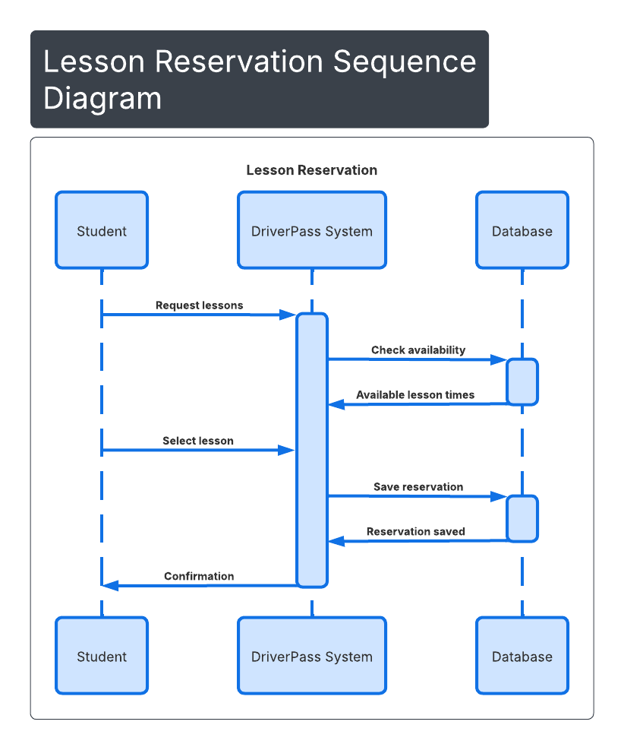

UML Class Diagram
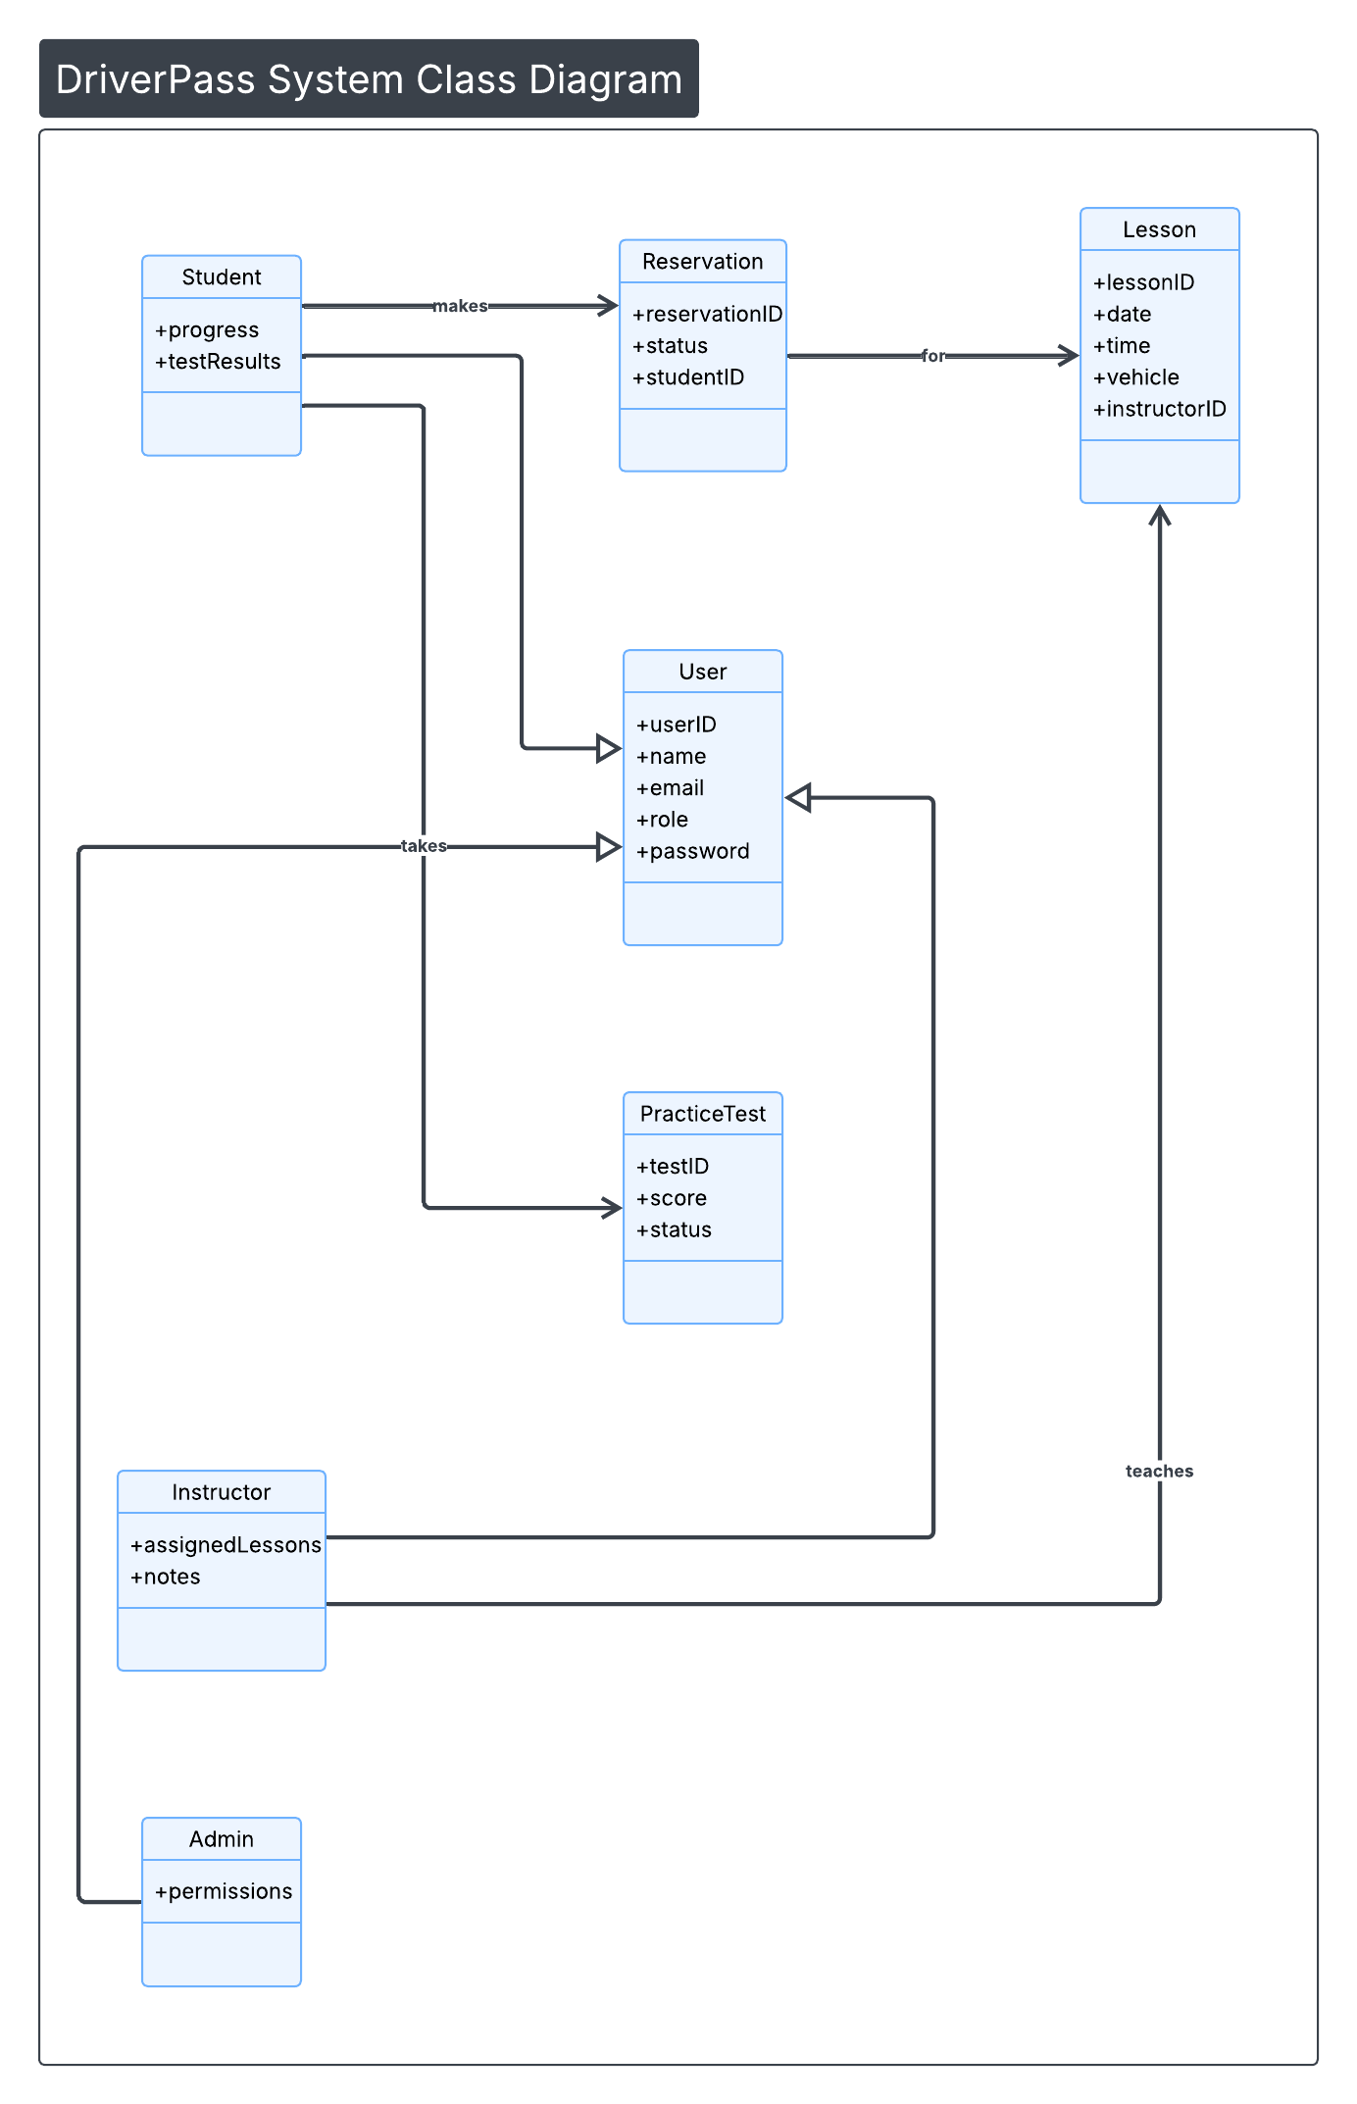

Technical Requirements
Technical Requirements
The DriverPass system will be implemented as a cloud-based web application to provide secure and scalable access for students, instructors, administrators, and management. Because the system must support scheduling, online practice testing, and user account management, it will be accessible through modern web browsers on desktop and mobile devices.
Hardware Requirements:
End users will require an internet-connected device such as a desktop computer, laptop, tablet, or smartphone. On the backend, the system will rely on cloud-hosted servers that provide processing power, storage, and high availability. Cloud hosting ensures the platform can support multiple users simultaneously scheduling lessons, taking practice exams, and accessing training materials.
Software Requirements:
The system will include a web server and application layer that manage core functionality such as user authentication, lesson scheduling, reservation tracking, and practice test delivery. A relational database will store system data, including user accounts, roles, lesson assignments, reservations, instructor notes, and test results. The system will also support updates to reflect changes in DMV rules and testing standards.
Security and Access Control:
To meet DriverPass security requirements, the system will use secure login credentials and encrypted data transmission. Role-based access control will ensure that students, instructors, administrators, and IT staff can only access features appropriate to their role. The system will include password reset functionality, account lockout after repeated failed login attempts, and secure storage of sensitive user information. Activity tracking and audit logs will record reservation changes and administrative actions.
Infrastructure and Tools:
The platform will be deployed in a cloud environment to reduce maintenance overhead and improve scalability. Cloud infrastructure will provide automated backups, monitoring, and logging to ensure reliability and support system growth. Development and modeling tools include UML diagramming software such as Lucidchart and standard documentation tools for maintaining system design artifacts.

